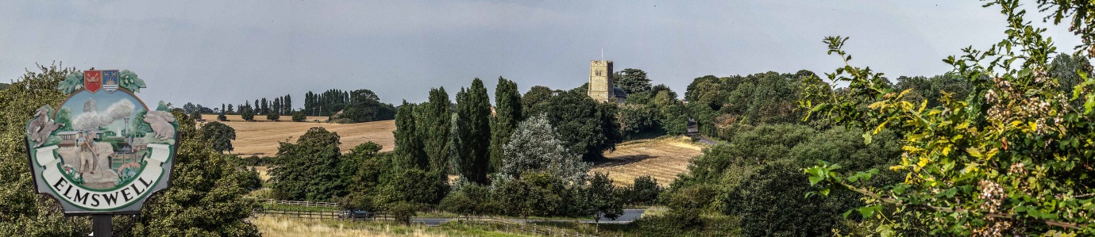

Elmswell Neighbourhood Plan
MINUTES
of the Steering Group meeting held on
11th June 2014 at The Blackbourne
Present: Marian Abbott, Philip Blissett, Neil Brown, Julie Cole, Peter Dow, Peter Edmonds,
Mary Feeney, Terry Garner, Peter Goodridge, Sarah Mansel (Ch.), Fred Pallett,
Shaun Pratt, Ann Richards,
Attending: Gillian Benjamin
1. There were no apologies for absence.
2. The Minutes of the last meeting held on 22nd April were approved as a true record.
3. The Meeting received a report on Annual Parish Meeting (APM) held on 14th May, by
way of the Minutes referred to the Group from the Annual Parish Council meeting on
29th May. It was accepted that the prominence of the impending Bacon Factory
development and the widespread support for a relief road were overwhelming factors
emerging, as before, from the public.
There was discussion regarding the emerging Community Infrastructure Levy (CIL)
which will augment or replace the current system for securing financial contributions
towards infrastructure provision from future development. It was noted that the
standard 15% CIL contribution handed to the local community would be increased to
25% if that community has a Neighbourhood Plan in place.
4. Considering the next steps, the following were noted, having taken account of APM
feedback:
4.1 The schedule of ‘Issues’ as refined by contributions from members was
accepted as a fair basis for developing the questionnaire;
4.2 The stakeholder analysis was revised so as to:
4.2.1 raise the profile of ‘Village Clubs & Organisations’ into the next-to-top
category re both influence on the Plan and most affected by the
outcomes;
4.2.2 include St John’s Church in the schedule of Village Clubs &
Organisations.
4.3 It was accepted that the Project Plan was on target.
5. It was agreed that the next steps should centre on the customisation of draft questions
culled by Gillian Benjamin from the CAS database upon which the questionnaire will be
based. Three different sets of questions will be emailed across to members for review
towards discussion at the next meeting. Once determined, this will inform the process
of identifying groups to be consulted individually to establish the range and suitability of
the enquiries.
6. Peter Goodridge and Julie Cole confirmed progress towards linking the Plan process to
social media and a website.
7. The meeting noted correspondence regarding the system of establishing procedures
and numbers for pupil intake within SCC with reference to recent difficulties outlined by
a parent in a letter to the Parish Council and referred on to the Group as relevant to the
Plan process. There was well informed discussion which helped outline current
procedures and constraints on individual schools. The Secretary was asked to contact
SCC to confirm the process whereby a school’s allocated Pupil Admission Number
might be reviewed.
8. The following was noted when any other business was invited for discussion, to be
noted or for inclusion on a future agenda:
8.1 The Secretary is to contact the Village Recorder towards sourcing plans which
indicate the growth of the village in the recent past;
8.2 The Secretary is to contact the Mid Anglia Rail Transport Association to try to
establish timetables for current rail freight traffic through Elmswell and projected
growth figures as the Ipswich Chord project develops and to sound out the
subsequent possibility for funding to ameliorate the effects of the growth on the
village;
8.3 The Secretary is to look out the Harrow Estates traffic stats.re the rail crossing
and to seek information towards possible web cam coverage to simplify an
independent survey;
8.3 Mary Feeney drew Members’ attention to the MSDC Planning website which
carries some interesting and illuminating comments from various agencies
regarding the Bacon Factory application for development;
8.4 Mary Feeney agreed to look out relevant traffic statistics from the most recent
School Travel plan.
9. It was agreed that the next meeting should be scheduled for Tuesday 1st July at
Blackbourne, beginning at 7.30. Apologies were noted in advance from Marian Abbott
and Gillian Benjamin.
10. The meeting closed at 9.10.

Peter Dow

